Name_______________________________ Period ___________________ Date __________________

**DNA Research: A Timeline of Discovery & Developments**

*"This structure has novel features which are of considerable biological interest."*

This statement, perhaps the most scientific understatement, appeared in April 1953 in the scientific journal "Nature" when Watson and Crick presented the structure of the DNA-helix. In 1962, they shared Nobel Prize in Physiology or Medicine with Maurice Wilkins. Although Watson and Crick will go down in the history books for creating the first correct model of DNA many other scientist contributed to their discovery.

|  |  |
| --- | --- |
| **1866** | Gregor Mendel publishes results of his research on the inheritance of "factors" in pea plants. |
| **1869** | Friedrich Miescher discovers "nuclein" in the pus of discarded surgical bandages. |
| **1919** | Phoebus Levene identifies the base, sugar and phosphate nucleotide unit. |
| **1928** | Frederick Griffith discovers the transfer of traits in two forms of Pneumococcus. |
| **1937** | William Astbury produces the first X-ray diffraction patterns showing regular structure of DNA. |
| **1943** | Avery-MacLeod-McCarty experiment identifies DNA as the transforming principle. |
| **1952** | Hershey-Chase experiment shows that DNA is the genetic material of the T2 phage. |
| **1952** | Rosalind Franklin & Raymond Gosling produce single X-ray diffraction image. |
| **1953** | James Watson & Francis Crick suggest the first correct double-helix model of DNA structure. |
| **1958** | Meselson-Stahl experiment confirms replication mechanism as implied by the double-helical structure. |
| **1962** | Watson, Crick, and Wilkins jointly receive the Nobel Prize in Physiology or Medicine. |

**Part I - Transforming Principle**

**Can traits be passed from one organism to another?**

*By Martyn Shuttleworth*

**Introduction**[PDF version](https://explorable.com/printpdf/transforming-principle)[Share this page on your website](https://explorable.com/transforming-principle)

Frederick Griffith, established that there was a transforming principle in bacterial genetics in a ground-breaking experiment, performed in 1928.

He postulated that information could somehow be transferred between different strains of bacteria. This was long before the discovery of DNA and was an inspired piece of scientific detective work.

**Methodology**

For this study, Griffith used two strains of Pneumococcus bacteria, type III-S and type II-R.

There is one major difference between these two types; the III-S strain has a smooth polysaccharide coat which makes it resistant to the immune system of mice, whereas the II-R strain lacks this coat and so will be destroyed by the immune system of the host.

For the first stage of the [transforming principle experiment](http://en.wikipedia.org/wiki/Griffith%27s_experiment), Griffith showed that mice injected with III-S died but when injected with II-R lived and showed few symptoms.

The next stage showed that if the mice were injected with type III-S that had been killed by heat, the mice all lived, indicating that the bacteria had been rendered ineffective.

The interesting results came with the third part of the experiment, where mice were injected with a mixture of heat killed III-S and live II-R.

Interestingly enough, the mice all died, indicating that some sort on information had been passed from the dead type III-S to the live type II-R. Blood sampling showed that the blood of the dead mice contained both live type III-S and live type II-R bacteria.

Somehow the type III-S had been transformed into the type III-R strain, a process he christened the transforming principle.

**Discussion**

Follow up experiments performed by Avery, McLeod and McCarty and by Hershey and Chase established that DNA was the mechanism for this transferal of genetic information between the two bacteria.

In turn, this lead to the discoveries of Crick and Watson, who discovered the exact structure of DNA, and the mechanisms used for storing and transferring information.

Considering that Griffith did not know the chemical and biological processes behind the transforming principle, it was inspirational research which built on the theories of scientists such as [Mendel](https://explorable.com/law-of-segregation). The study opened up avenues of research into the biochemical principles behind the genetic transference of information.

Genetic engineering, involving the transferring of DNA between organisms, is now more commonplace, but built upon the research performed by Griffith. Most biology students have heard of Mendel, and Crick and Watson, but must not forget the work of the other inspiring scientists in between.

Source: https://explorable.com/transforming-principleTop of Form

Bottom of Form

**Reading Analysis Questions for “Transforming Principal”**

1. Based on the introduction, identify the scientist who came up with the transforming principal. Explain what “transforming principal” means and come up with a hypothesis for this experiment.

**Scientist:**

**Explanation:**

**Hypothesis:**

1. Draw a picture to identify the items placed in the control and experimental groups described in the methodology section.
2. Using evidence from the text, explain how Griffith was able to prove his “transforming principal”.

**Part 2 – Hershey-Chase Experiment**

**What is the molecule of heredity DNA or Protein?**

In 1944 Avery, MacLeod, and McCarty set out to prove that the fourth result of the Griffith experiment was due to an exchange of hereditary material. They found that the fourth phase of the Griffith experiment was due to the process of transformation. They explain that transformation is the process in which a section of hereditary information is passed from one bacteria to another.

Up until this time we knew that chromosomes pass on hereditary information. We also knew that chromosomes are made up of proteins and DNA. In 1952 Hershey and Chase set out to prove that DNA, not protein, was the molecule of heredity.

Watch this video and answer the questions below, to find out how:

<http://highered.mheducation.com/sites/9834092339/student_view0/chapter14/hershey_and_chase_experiment.html>

**Reading Analysis Questions for “Hershey Chase Experiment”**

1. Based on the video, identify the scientists who designed this experiment. Explain what they were trying to prove, and come up with a hypothesis for their experiment.

**Scientist:**

**Explanation:**

**Hypothesis:**

1. Using the video, draw a picture to identify the methodology used in this experimental design. Be sure to identify all control and experimental groups.
2. Using evidence from the video describe the findings that resulted from the Hershey-Chase Experiment.

**Part 3 – Watson and Crick**

**DNA the Molecule of Heredity**

According to the New York Times, the transcribed letter, found on the last pages of this packet, was written by Francis Crick to his 12-year-old son, Michael on March 19, 1953. The letter contains the first written description of DNA as a code for life itself. Read the letter and use the text to describe the structure and importance of the molecule of DNA.

**Reading Analysis Questions for “Watson and Crick”**

1. What two scientists were credited for creating the model of DNA?
2. What is DNA?
3. What does DNA stand for?
4. Based on Francis Crick’s explanation to his son, describe the structure of DNA?
5. Draw Crick’s illustration of the structure of DNA.
6. What are the four bases found in DNA?
7. What is so “exciting” about the base pairings?
8. Why do they believe DNA is a code?

**Part 4 – Rosalind Franklin and X-Ray Crystallography**

Rosalind Franklin always liked facts. She was logical and precise, and impatient with things that were otherwise. She decided to become a scientist when she was 15. She passed the examination for admission to Cambridge University in 1938, and it sparked a family crisis. Although her family was well-to-do and had a tradition of public service and philanthropy, her father disapproved of university education for women. He refused to pay. An aunt stepped in and said Franklin should go to school, and she would pay for it. Franklin's mother also took her side until her father finally gave in.

War broke out in Europe in 1939 and Franklin stayed at Cambridge. She graduated in 1941 and started work on her doctorate. Her work focused on a wartime problem: the nature of coal and charcoal and how to use them most efficiently. She published five papers on the subject before she was 26 years old. Her work is still quoted today, and helped launch the field of high-strength carbon fibers. At 26, Franklin had her PhD and the war was just over. She began working in x-ray diffraction -- using x-rays to create images of crystalized solids. She pioneered the use of this method in analyzing complex, unorganized matter such as large biological molecules, and not just single crystals.

She spent three years in France, enjoying the work atmosphere, the freedoms of peacetime, the French food and culture. But in 1950, she realized that if she wanted to make a scientific career in England, she had to go back. She was invited to King's College in London to join a team of scientists studying living cells. The leader of the team assigned her to work on DNA with a graduate student. Franklin's assumption was that it was her own project. The laboratory's second-in-command, Maurice Wilkins, was on vacation at the time, and when he returned, their relationship was muddled. He assumed she was to assist his work; she assumed she'd be the only one working on DNA. They had powerful personality differences as well: Franklin direct, quick, decisive, and Wilkins shy, speculative, and passive. This would play a role in the coming years as the race unfolded to find the [structure of DNA](http://www.pbs.org/wgbh/aso/databank/entries/do53dn.html).

Franklin made marked advances in x-ray diffraction techniques with DNA. She adjusted her equipment to produce an extremely fine beam of x-rays. She extracted finer DNA fibers than ever before and arranged them in parallel bundles. And she studied the fibers' reactions to humid conditions. All of these allowed her to discover crucial keys to DNA's structure. Wilkins shared her data, without her knowledge, with James Watson and [Francis Crick](http://www.pbs.org/wgbh/aso/databank/entries/bocric.html), at Cambridge University, and they pulled ahead in the race, ultimately publishing the proposed structure of DNA in March, 1953.

The strained relationship with Wilkins and other aspects of King's College (the women scientists were not allowed to eat lunch in the common room where the men did, for example) led Franklin to seek another position. She headed her own research group at Birkbeck College in London. But the head of King's let her go on the condition she would not work on DNA. Franklin returned to her studies of coal and also wrapped up her DNA work. She turned her attention to viruses, publishing 17 papers in five years. Her group's findings laid the foundation for structural virology.

While on a professional visit to the United States, Franklin had episodes of pain that she soon learned were ovarian cancer. She continued working over the next two years, through three operations and experimental chemotherapy and a 10-month remission. She worked up until a few weeks before her death in 1958 at age 37.

Source: <http://www.pbs.org/wgbh/aso/databank/entries/bofran.html>

**Reading Analysis Questions for “Rosalind Franklin and X-Ray Crystallography”**

1. Who is Rosalind Franklin? How did she contribute to the creation of the first model of DNA?
2. Using evidence from the reading, explain why her contribution may be considered a controversial topic.
3. Based on your exploration of the discovery of DNA as the molecule of heredity, elaborate on this quote “Most biology students have heard of Mendel, and Crick and Watson, but must not forget the work of the other inspiring scientists in between.”

***Personal Letter from Francis Crick to his son***

19 Portugal Place Cambridge  
19 March ’53

My Dear Michael,

Jim Watson and I have probably made a most important discovery. We have built a model for the structure of de-oxy-ribose-nucleic-acid (read it carefully) called D.N.A. for short. You may remember that the genes of the chromosomes — which carry the hereditary factors — are made up of protein and D.N.A.

Our structure is very beautiful. D.N.A. can be thought of roughly as a very long chain with flat bits sticking out. The flat bits are called the “bases”. The formula is rather like this.

[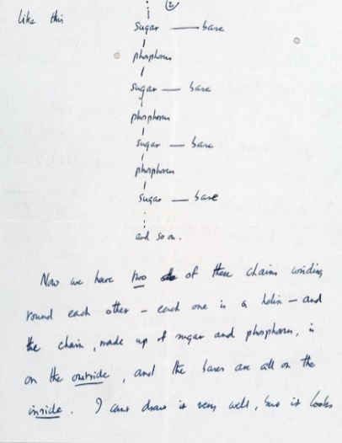](http://newswatch.nationalgeographic.com/files/2013/04/40015934_a_1.jpg)

Page 2. Photograph courtesy Christie’s

 Now we have two of these chains winding round each other — each one is a helix — and the chain, made up of sugar and phosphorus, is on the outside, and the bases are all on the inside. I can’t draw it very well, but it looks like this

[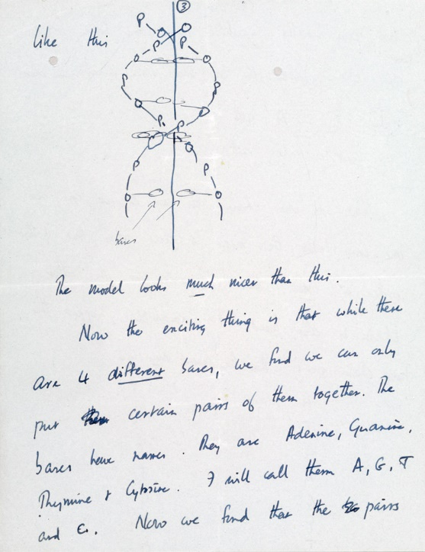](http://newswatch.nationalgeographic.com/files/2013/04/40015934_b_1.jpg)

Page 3. Photograph courtesy Christie’s

The model looks much nicer than this.

Now the exciting thing is that while these are 4 different bases, we find we can only put certain pairs of them together. Thee bases have names. They are Adenine, Guanine, Thymine & Cytosine. I will call them A, G, T and C. Now we find that the pairs we can make — which have one base from one chain joined to one base from another — are

only A with T and G with C.

[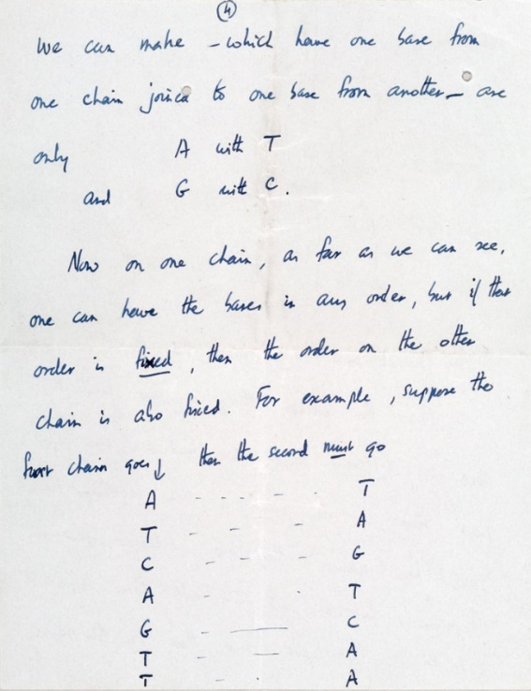](http://newswatch.nationalgeographic.com/files/2013/04/40015934_c_1.jpg)

Page 4. Photograph courtesy Christie’s

 Now on one chain, as far as we can see, one can have the bases in any order, but if their order is fixed, then the order on the other chain is also fixed. For example, suppose the first chain goes [points to string of letters on left], then the second must go [points to string of letters on right].

[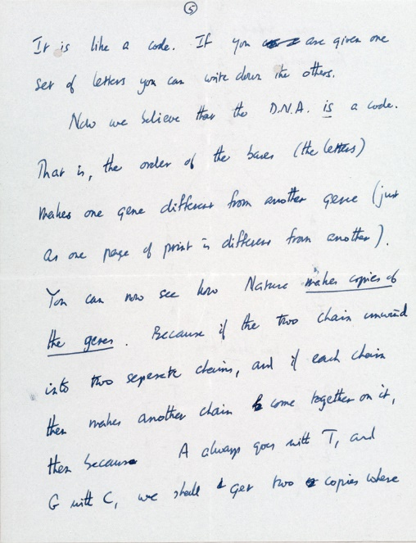](http://newswatch.nationalgeographic.com/files/2013/04/40015934_d_1.jpg)

Page 5. Photograph courtesy Christie’s

 It is like a code. If you are given one set of letters you can write down the others.

[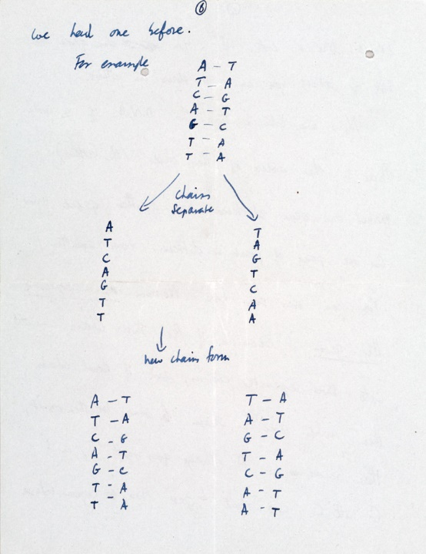](http://newswatch.nationalgeographic.com/files/2013/04/40015934_e_1.jpg)Now we believe that the D.N.A. is a code. That is, the order of the bases (the letters) makes one gene different from another gene (just as one page of print is different from another). You can now see how Nature makes copies of the genes. Because if the two chains unwind into two separate chains, and if each chain then makes another chain come together on it, then because A always goes with T, and G with C, we shall get two copies where we had one before. For example

Page 6. Photograph courtesy Christie’s

[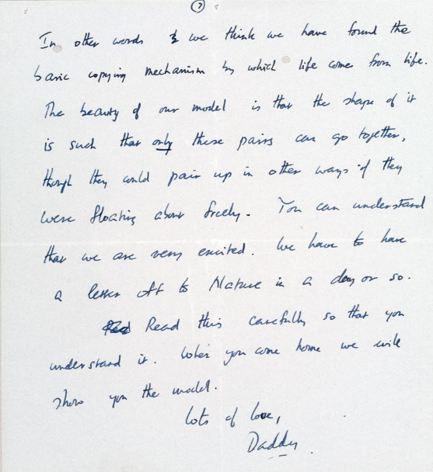](http://newswatch.nationalgeographic.com/files/2013/04/40015934_f_1.jpg)

Page 7. Photograph courtesy Christie’s

 In other words we think we have found the basic copying mechanism by which life comes from life. The beauty of our model is that the shape of it is such that only these pairs can go together, though they could pair up in other ways if they were floating about freely. You can understand that we are very excited. We have to have a letter off to Nature in a day or so. Read this carefully so that you understand it. When you come home we will show you the model.

Lots of love, Daddy